DBMS lab-5

**PLSQL Procedures**

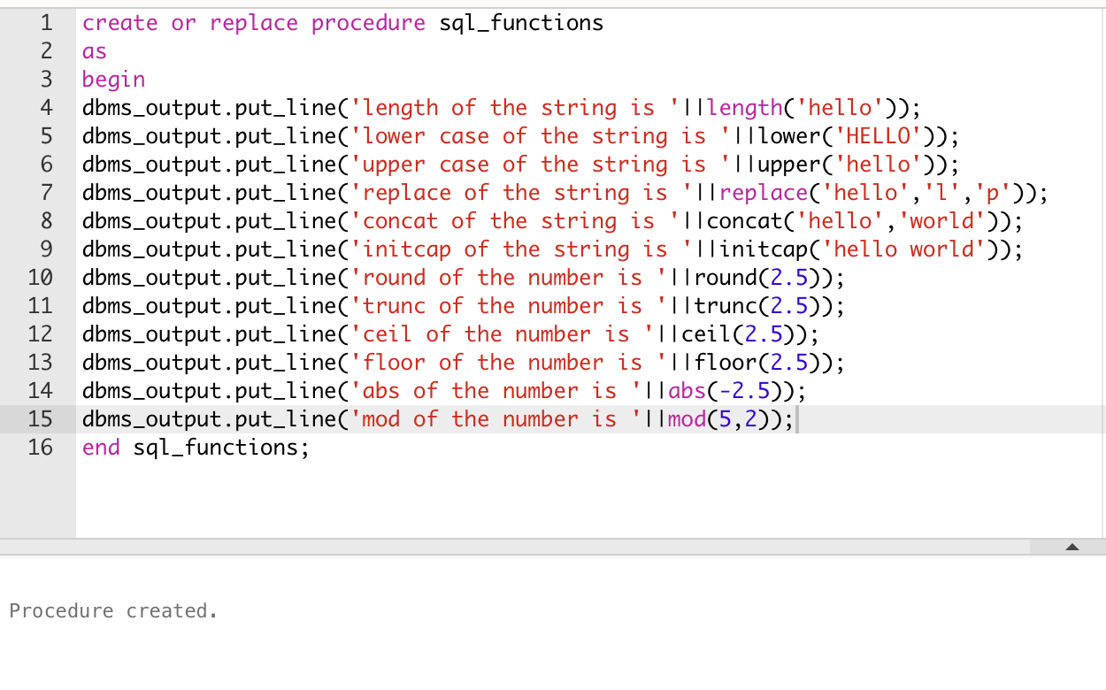

**Execute the procedure**

